Assignment 10
PNR: 260740150018
Name: PRATIK SUNIL ABHANG
Question:
An e-commerce platform passes item details to a checkout pipeline using dictionaries.
Write a function validate_checkout_item(item_dict) that processes items like {"name": "Laptop", "price": 1200.00, "quantity": 2}:
• Use standard structural logic to verify if the essential keys (name, price, quantity) exist. If any are missing, manually raise a KeyError specifying which key was dropped.
• Use an assert statement to confirm that quantity is an integer greater than 0.
• Use a second assert statement to confirm that price is a float or integer greater than 0.
• Wrap the logic in a try...except (KeyError, AssertionError) as error: block to print a custom failure message, then re-raise the error for the main application to log.
Program
def validate_checkout_item(item_dict):
try:
for key in ("name", "price", "quantity"):
if key not in item_dict:
raise KeyError(f"Missing key: {key}")
assert isinstance(item_dict["quantity"], int) and item_dict["quantity"] > 0
assert isinstance(item_dict["price"], (int, float)) and item_dict["price"] > 0
return True
except (KeyError, AssertionError) as error:
print(f"Validation failed: {error}")
raise
default_item = {"name": "Laptop", "price": 1200.00, "quantity": 2}
print(validate_checkout_item(default_item))
user_item = {
"name": input("Enter name: "),
"price": float(input("Enter price: ")),
"quantity": int(input("Enter quantity: "))
}
print(validate_checkout_item(user_item))

Input and Output
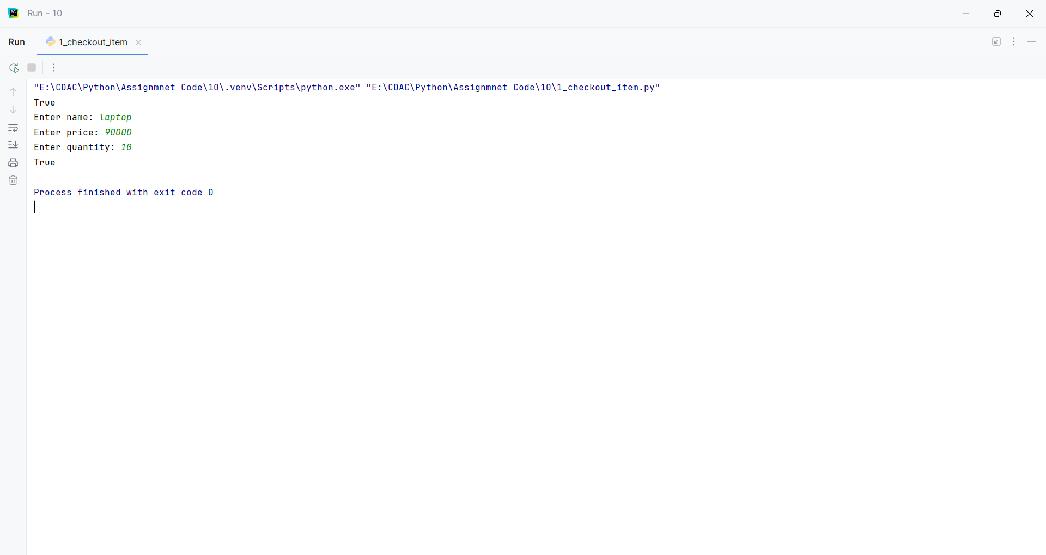
Question:
You are writing a metrics engine that processes a monthly sales file (sales_data.csv). If the file is missing, the system should look for a default backup file (backup_data.csv).
Write a function process_monthly_report(filename) that:
• Tries to open and read the file specified by filename.
• Uses a try...except FileNotFoundError: block to catch a missing file. When caught, it should print a warning and attempt to open backup_data.csv instead.
• If the backup file is also missing, raise a custom runtime error named DataMissingError with the message "No source data or backup files available."
• Uses a finally block to ensure that if any file stream was successfully opened. also give me corect python fiel and correct with no comnents and as per the question only
Program
class DataMissingError(RuntimeError):
pass
def process_monthly_report(filename):
file_stream = None
try:
try:
file_stream = open(filename, "r")
return file_stream.read()
except FileNotFoundError:
print("Warning: Source file not found. Trying backup_data.csv instead.")
try:
file_stream = open("backup_data.csv", "r")
return file_stream.read()
except FileNotFoundError:
raise DataMissingError(
"No source data or backup files available."
)
finally:
if file_stream is not None:
file_stream.close()
filename = input("Enter sales filename: ")
try:
print(process_monthly_report(filename))
except DataMissingError as error:
print(error)

Input and Output
